[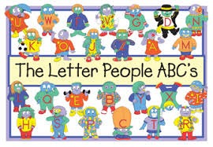](https://www.google.com/url?sa=i&rct=j&q=&esrc=s&frm=1&source=images&cd=&cad=rja&uact=8&docid=A5BgaznGuwXgOM&tbnid=OVqWyoiDNzURJM:&ved=0CAcQjRw&url=https://www.abramslearningtrends.com/products/abcs-big-book&ei=saEpVKqAK6TUiwLoxIGYAQ&bvm=bv.76247554,d.aWw&psig=AFQjCNEy6FqjM8KZAgakuGuvlryELBhyTg&ust=1412100903817930)

A research-based, developmentally appropriate, comprehensive Pre-K curriculum. Kid-friendly and teacher-approved, Let’s Begin with the Letter People helps early learners develop the strong foundation they’ll need for reading and writing success in today’s much more rigorous kindergarten classrooms.

Here are a few of the benefits:

* Thematically organized
* Integrated learning across language and literacy, math, science, and social-emotional development.
* Explicit, easy to follow lessons
* Oral language and listening skills.
* Print awareness
* Phonological and phonemic awareness
* Alphabet knowledge: letter identification and sound symbol association
* Vocabulary development
* Writing and spelling